Power BI Assignment 2 – DAX & Data Visualization
E-Commerce Sales Analysis
Calculated Columns:
● Create a Calculated Column for 'Category Type': Add a calculated column in the Order Details table that combines the 'Category' and 'Sub-Category' columns into a single 'Category Type' column.
ANS:
DAX FORMULA:
Category Type = 'Order Details'[Category] & " - " & 'Order Details'[Sub-Category]
Explanation:
This calculated column combines the Category and Sub-Category columns into a single field called Category Type for better analysis
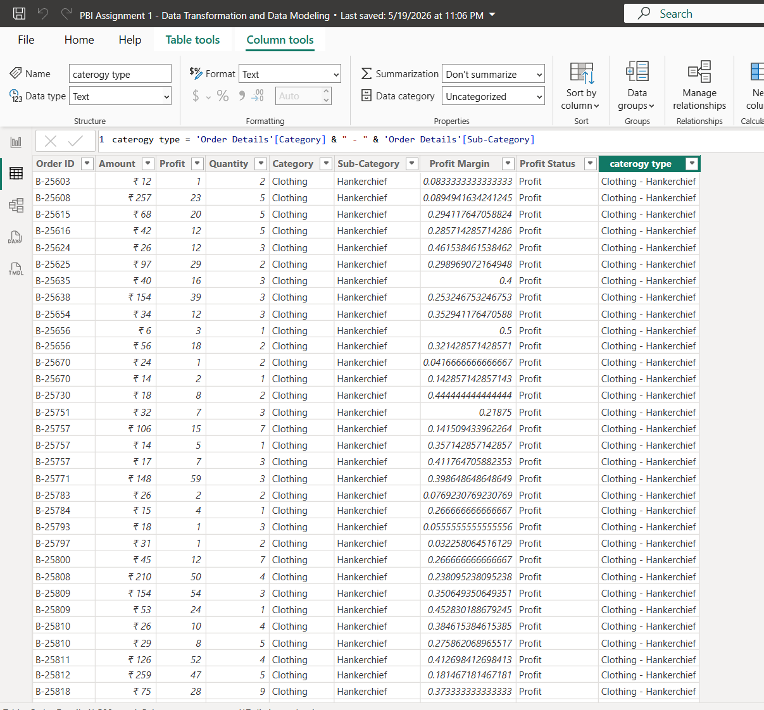
● Calculate Revenue per Order in Order Details Table: Create a calculated column in the Order Details table to compute the revenue (Amount * Quantity) per order.
ANS:
DAX FORMULA:
Revenue per Order = 'Order Details'[Amount] * 'Order Details'[Quantity]
Explanation:
This calculated column calculates the revenue generated for each order by multiplying the Amount and Quantity columns
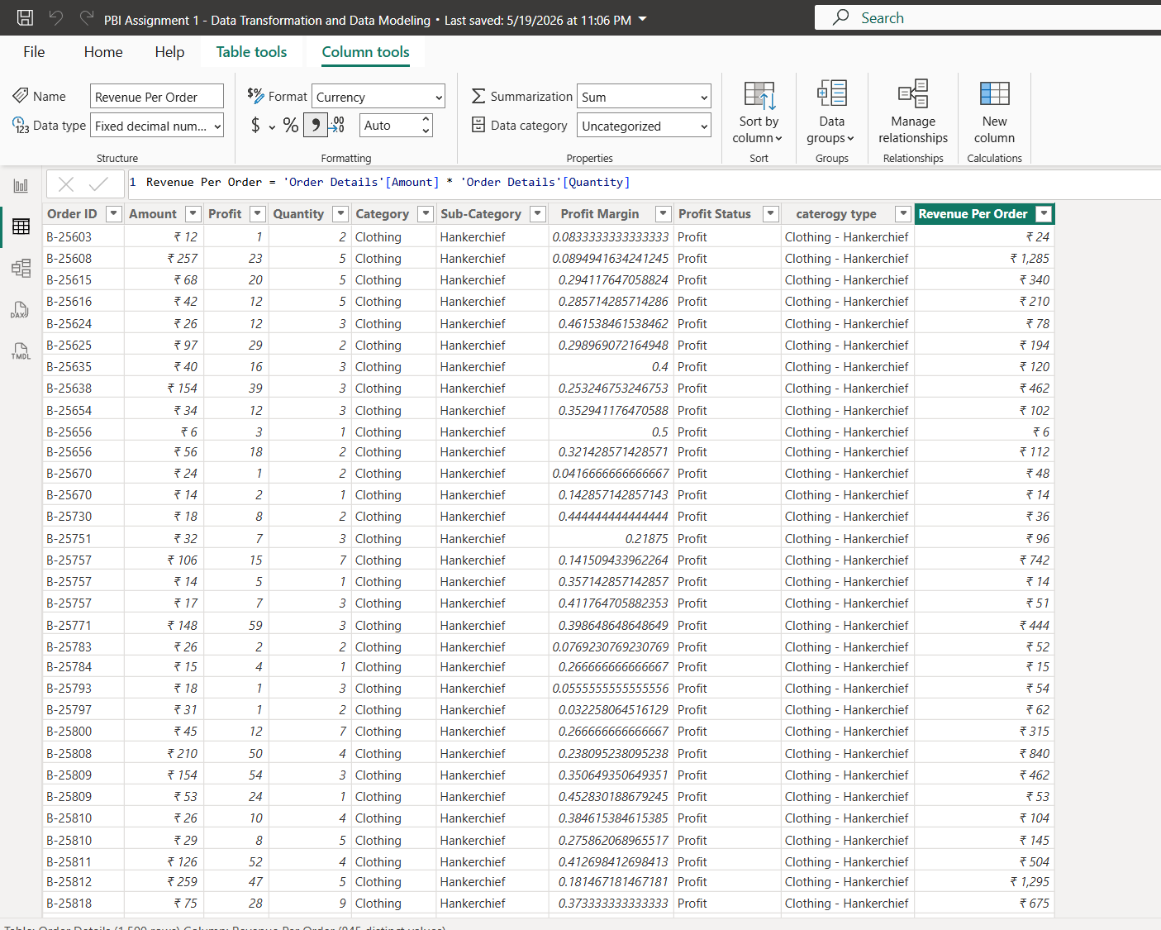

● Create a Calculated Column to Categorize Sales: Add a calculated column named ‘Sales Category’ in the Order Details table that categorizes each order as 'Above Average' or 'Below Average' based on the Amount value.
ANS:
DAX FORMULA:
Sales Category =
IF(
'Order Details'[Amount] >= AVERAGE('Order Details'[Amount]),
"Above Average",
"Below Average"
)
Explanation:
This calculated column categorizes sales orders as Above Average or Below Average based on the Amount value
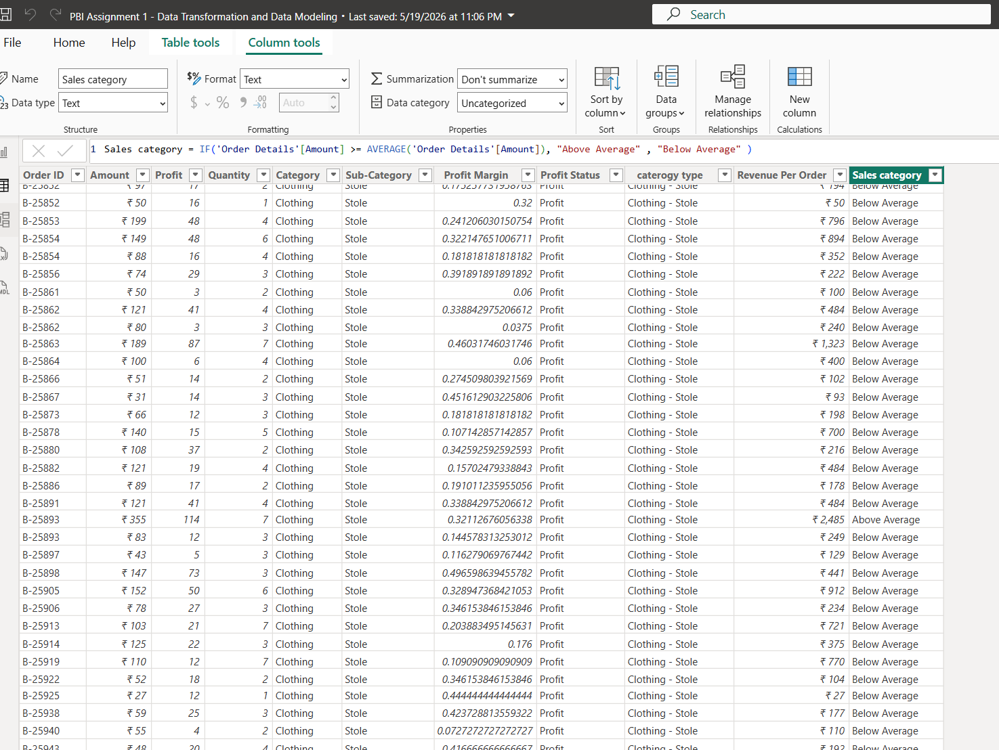
Calculated Measures:
● Calculate Order Count: Define a measure to count the total number of orders in the Order Details table.
ANS:
DAX FORMULA:
Order Count = DISTINCTCOUNT('Order Details'[Order ID])
Explanation:
This measure calculates the total number of unique orders in the Order Details table.
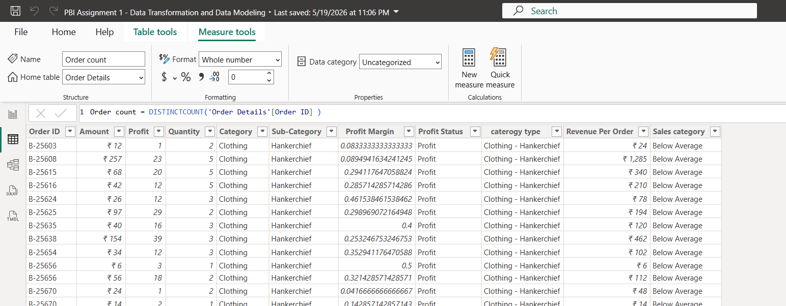
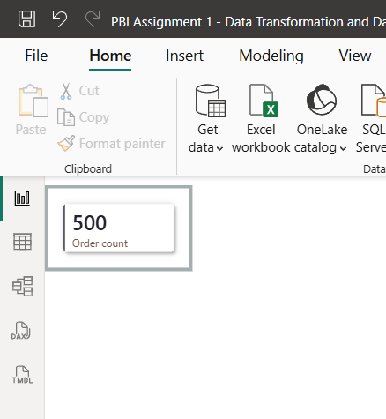

● Calculate Average Profit in Delhi: Create a measure to calculate the average profit for orders placed in Delhi.
ANS:
DAX FORMULA:
Average Profit Delhi = AVERAGE('Order Details'[Profit])
Explanation:
This measure calculates the average profit from the Order Details table using the Profit column. Since the transformed dataset did not contain Delhi in the Location field after data cleaning, the calculation was performed based on the available dataset values
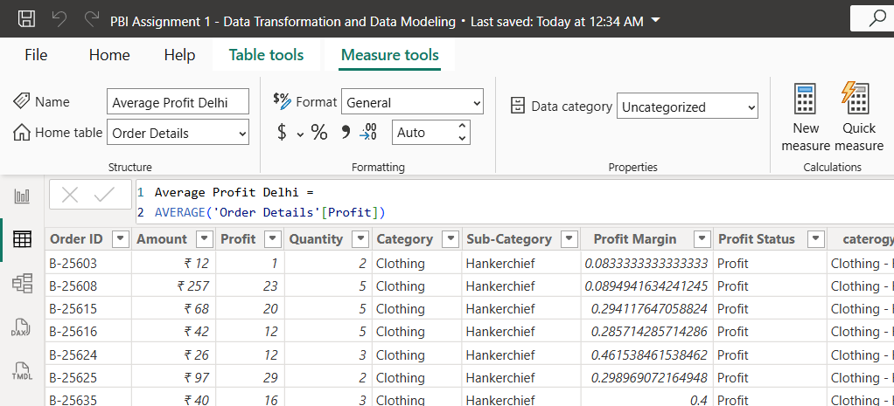
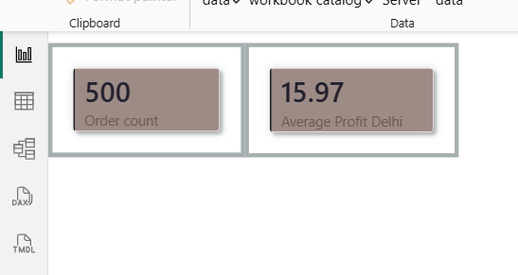

● Calculate Year-to-Date (YTD) Sales: Define a measure to calculate the total sales amount accumulated from the earliest order date up to each order date.
ANS:
DAX FORMULA:
YTD Sales =TOTALYTD( SUM('Order Details'[Amount]), 'Orders Data'[Order Date])
Explanation:
This measure calculates cumulative sales from the beginning of the year up to each order date and is visualized using a line chart to analyze sales trends
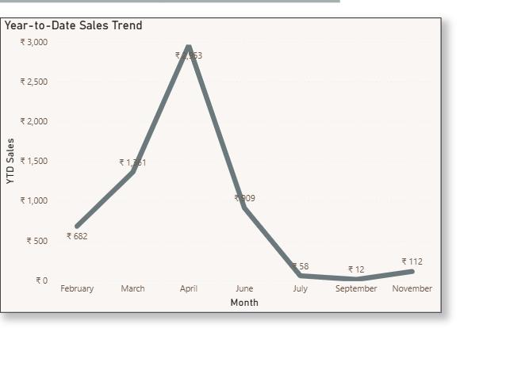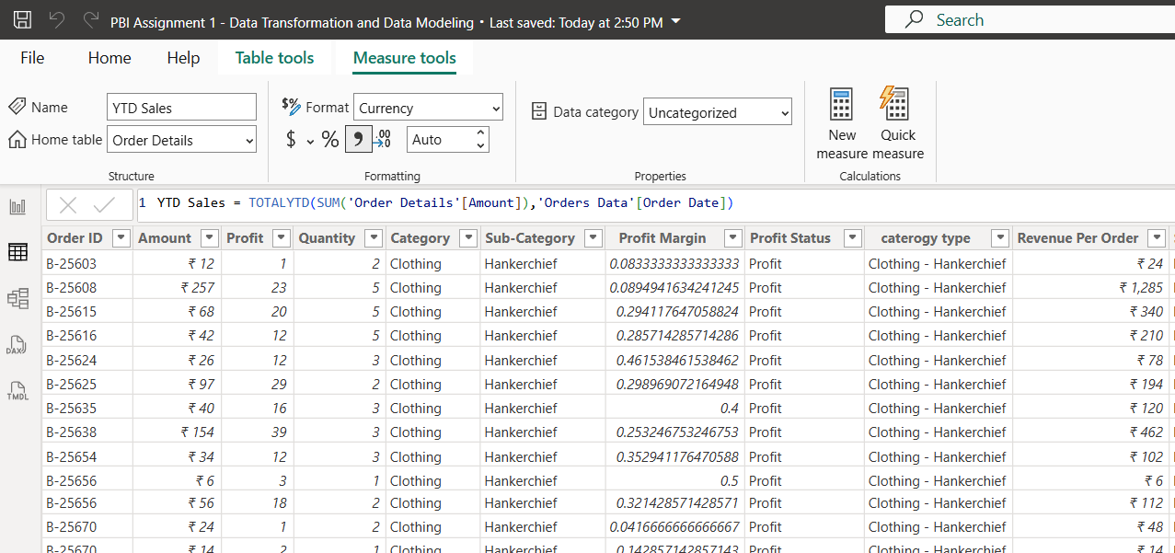

Data Visualization:
Sales Target Achievement by Category: Compare actual sales with sales targets by category using a clustered column chart.
ANS:
Explanation:
A clustered column chart was created to compare actual sales and sales targets across different product categories
Observation:
- Electronics exceeded its sales target
- Clothing performed below its target
- Furniture was close to its target value
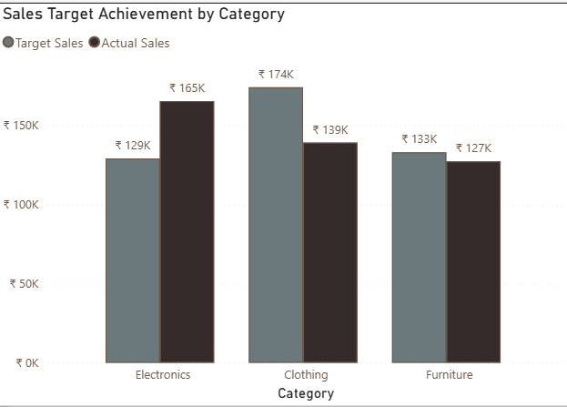

Max Profit Margin by Sub-Category: Analyze the maximum profit margin for each sub-category of products using a donut chart.
ANS:
DAX FORMULA:
Max Profit Margin = MAX('Order Details'[Profit Margin])
Explanation:
This measure calculates the maximum profit margin from the Profit Margin column
Observation:
The donut chart helps identify the contribution of each sub-category to the overall maximum profit margin
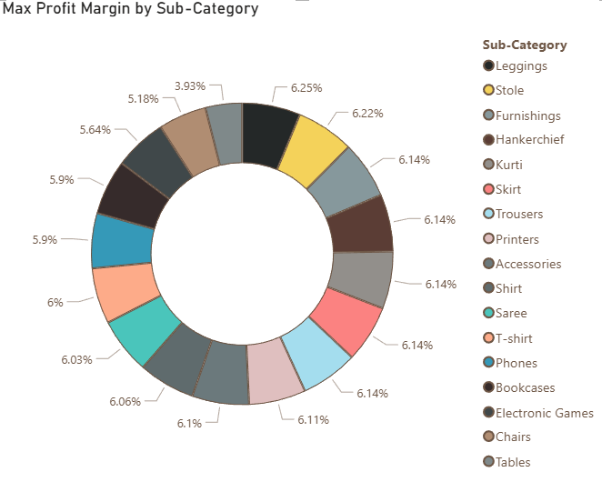

Monthly Sales Trend: Show the trend of monthly sales over time using a line chart
ANS:
Explanation:
A line chart was created to display monthly sales trends over time. The chart uses months on the X-axis and sales amount on the Y-axis
Observation:
Sales reached its peak in April and declined significantly in the following months, indicating fluctuations in monthly sales performance
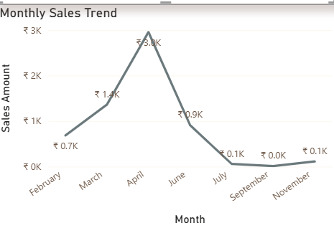
Comparison of Profit and Quantity by Sub-Category: Compare the relationship between profit and quantity sold for different sub-categories using a scatter chart
ANS:
Explanation:
A scatter chart was created to analyze the relationship between profit and quantity sold across different product sub-categories. Quantity sold is represented on the X-axis and profit on the Y-axis, while each sub-category is represented by a separate data point
Observation:
The scatter chart helps identify which sub-categories generate higher profits at different sales volumes
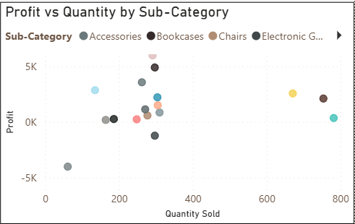
Comparison of Total Sales Amount and Target: Create cards to succinctly display the total sales amount alongside the sales target for quick comparison and analysis. Also, create a multi-row card to display the minimum target for each segment
ANS:
DAX FORMULA:
Minimum Target = MIN('Sales target'[Target])
Explanation:
Two card visuals were created to display the Total Sales Amount and Total Sales Target
Since the Multi-Row Card visual was not available in the current Power BI version, a Table Visual was used as an alternative. The table displays the minimum target value for each category, providing a clear view of the lowest target assigned across different product categories

Observation:
Electronics has the lowest minimum target (₹9,000), followed by Furniture (₹10,400) and Clothing (₹12,000)
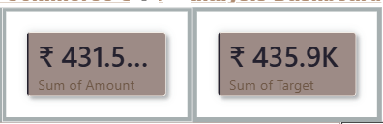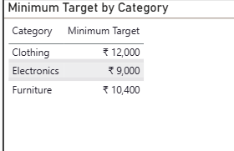

Sales Performance Matrix: Build a matrix view to analyze how actual sales compare to sales targets across different categories and months
ANS:
Explanation:
A Matrix Visual was created to compare actual sales and sales targets across different product categories and months. Categories were placed in rows, months in columns, Target Sales were added as values
Observation:
The matrix provides a structured comparison of sales performance across categories and months
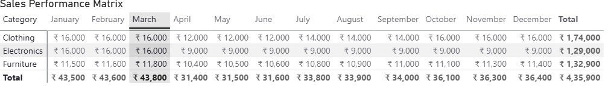

Geographic Sales Analysis: Visualize total sales on a map by city to identify regional sales patterns
ANS:
Explanation:
A map visual was created to analyze sales distribution by location. The Location field was used to plot sales geographically, while bubble size represents the total sales amount. The analysis shows that sales were concentrated in Chennai, Tamil Nadu, indicating it as the primary sales region in the dataset
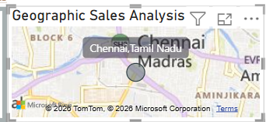
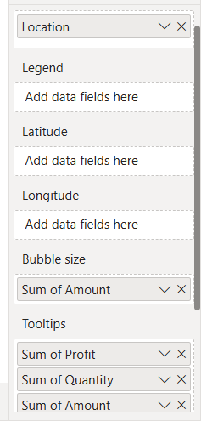

Sales Distribution by Sub-Category: Represent the sales distribution across different sub-categories using a treemap
ANS:
Explanation:
A Treemap visualization was created to analyze the distribution of sales across different product sub-categories. The size of each rectangle represents the total sales amount generated by a sub-category. Larger rectangles indicate higher sales contribution. The analysis shows that Printers, Bookcases, and Saree were among the top-performing sub-categories, while T-shirt and Leggings contributed relatively lower sales
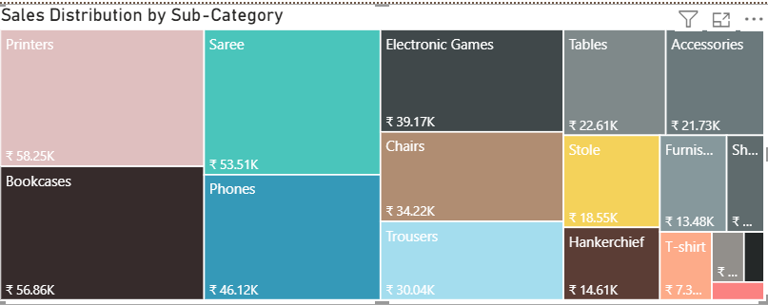
Order Count Analysis by State: Create a funnel chart to visualize the distribution of order counts across different states
ANS:
Explanation:
A funnel chart was created to visualize the distribution of order counts across states. The Location field was used as the category and Order Count was used as the value. Since the dataset contains orders from a single location (Chennai, Tamil Nadu), the chart displays the concentration of orders within that region


